TripAdvisor Project
Introduction
Tripadvisor is one of the world’s most influential travel platforms providing a massive ecosystem powered by user-generated content. Travelers share reviews and ratings on restaurants, hotels, and attractions, shaping the visibility and credibility of businesses.
Restaurants on Tripadvisor are graded on a 1–5 “bubble rating” scale, where 5 represents excellent and 1 reflects terrible. These ratings, together with the number and recency of reviews, determine a restaurant’s popularity ranking.
For this project, I focused on Italian restaurants, aiming to explore what separates high-performing establishments, those consistently rated 4.5 and above with strong review counts, from the rest.

- Data Preparation - Building a Reliable Foundation
When I first examined the dataset, I quickly realized that it was rich but messy, full of missing values, mixed data types, and string fields that hid complex structures (lists, ranges, or categorical text). My goal was to transform this semi-structured raw data into a clean, consistent table ready for machine learning.
At the same time, I wanted to preserve as much information as possible for later feature engineering.
Main actions at this stage:
  - Downsizing the scope and First Impressions
Due to the massive size of the full European dataset, I began by narrowing the dataset to restaurants located in Italy. This allowed me to maintain regional consistency while keeping processing times reasonable.
The original dataset consists of 42 columns providing data about geographic hierarchy and business attributes. No additional external data source was added.
  - Cleaning the Text and Structure
Many columns contained messy text with inconsistent casing, punctuation, or extra spaces. To fix that, I built helper functions:
- to remove punctuation with or without keeping spaces,
- to standardize spacing and casing,
- to parse list-like strings (for example, cuisines or tags),
- and to handle Yes/No or “Unclaimed” flags consistently.
This gave me reusable cleaning tools I could apply across different feature types.
  - Handling Geographic Hierarchies
Tripadvisor’s data often mixes granular and inconsistent location information.
Using original_location, region, province, and city, I rebuilt a clean hierarchy based on filling missing values intelligently, keeping only the top 1 city and province per region, and mapping regions to Italy’s macro-areas: North, Center, South, and Islands.
This maintained geographical context without exploding categorical cardinality.
  - Turning List Columns into Features
Columns like top_tags, cuisines, and features contained lists of words describing restaurant styles, dishes, and amenities.
Rather than explode every possible value, I extracted the Top N (5-6) most common items and created dummy variables for those, grouping the rest into an “other” category.
This kept the feature space compact while preserving the essence of each restaurant’s character.
  - Defining the Target
The target variable defined “success” as:
1 if avg_rating ≥ 4.5 and total_reviews_count > mean(total_reviews_count)
0 otherwise
This definition captured both quality and credibility, meaning restaurants that are well-rated and widely reviewed
reviews.
  - Final Dataset
After dropping several fields due to high level of missings, strings etc., I saved three core artifacts: main cleaned dataset (df_main.pkl), preserved text-rich originals for feature engineering (df_saved_columns.pkl) and columns intentionally excluded (df_full_dropped_columns.pkl).
2. Exploratory Data Analysis (EDA) — Seeing the Story Behind the Data
The EDA phase aimed to transform the data into understanding by identifying patterns, redundancies, and potential predictive signals.
  - Rating Redundancies
Plots of experience-based columns (food, service, value, atmosphere) against the target revealed monotonic increases suggesting restaurants with high experience scores almost always belonged to the “success” class.
These variables effectively leaked the target definition, so they were flagged for later exclusion in modeling.
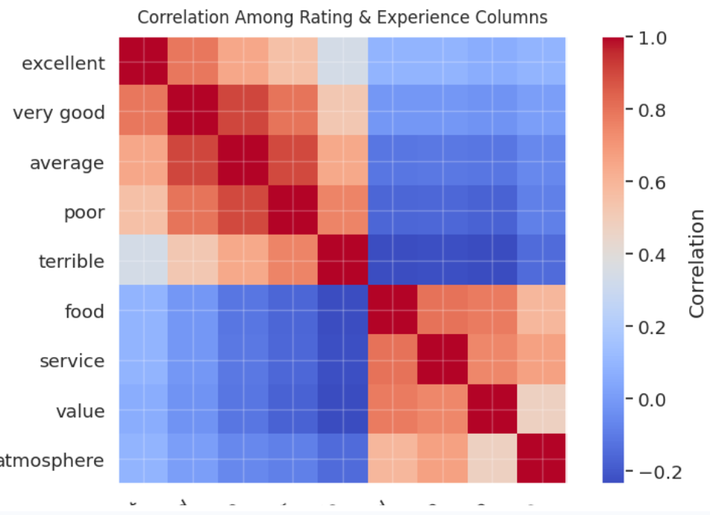
  - Categorical Insights
I analyzed key categoricals like region, province, city, and default_language.
Regions in central Italy tended to outperform others, suggesting economic or tourism-driven effects.
Restaurants with English-language profiles had notably higher success rates — a strong proxy for international visibility.
  - Numeric Distributions
Most numeric measures showed strong right skewness or heavy-tailed patterns, which would later influence how I handle scaling and outlier treatment.
  - Correlations and Redundancy
Correlation heatmaps helped detect duplicate signals (e.g., top_tags__italian mirrored cuisines__italian). Highly correlated pairs were marked for removal.
  - Statistical Testing
- Chi-square tests confirmed significant regional differences in success probability.
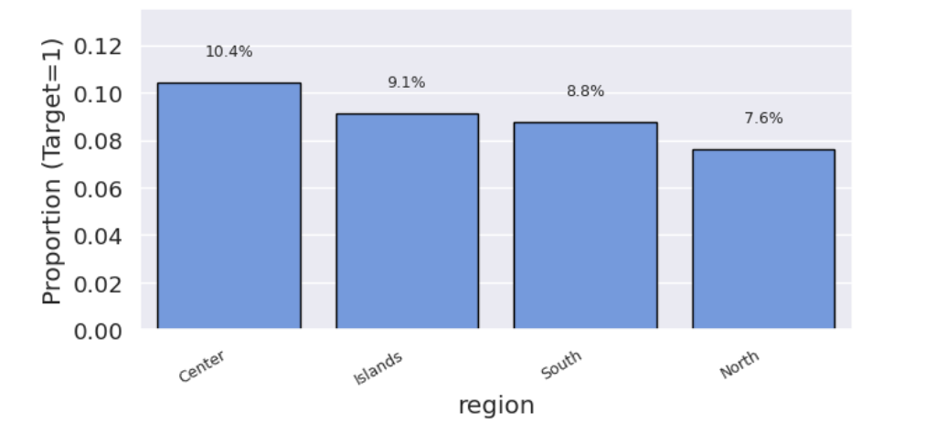
- Z-tests across binary variables (like is_michelin, vegan_options, is_gluten) quantified which factors were statistically associated with high ratings.
English-language visibility again emerged as a standout predictor.
- 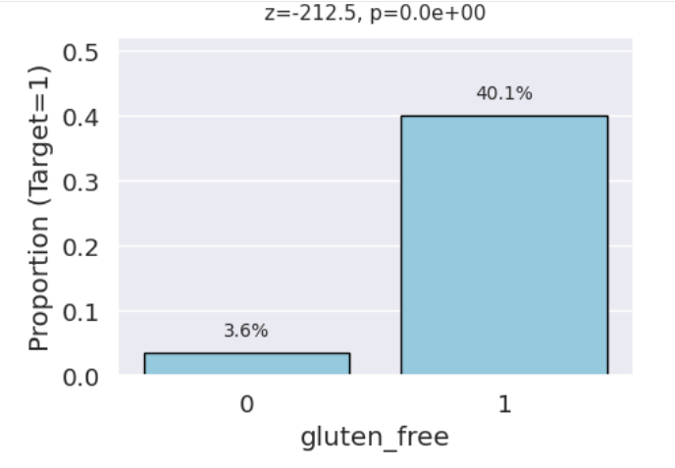

  - Key Insights Summarized
- Experience-based ratings (food, service, etc.) were planned to be dropped to avoid leakage.
- English-language visibility correlated strongly with success, most likely a proxy for international appeal.
- Regional patterns were significant: central Italy consistently performed better.
- Redundant variables (e.g., repeated cuisine tags) were removed to streamline later modeling.
- Some numeric distributions were heavily skewed, guiding the next stage toward transformation and outlier handling.

3. Handling Missing Data & Outliers — Making the Data Robust
3.1. Missing Data Strategy
I combined multiple targeted imputation methods:
- KNN Imputation for correlated operational metrics (open_hours_per_week, open_days_per_week)
- Median by group for max_price, grouped by price level. Based on max_price reorganization of price_range to accommodate new max_price distribution.
- City/province medians for missing coordinates
- “Unknown” placeholders for categorical nulls (“All languages” for default_language)
After imputation, missingness dropped sharply, and distributions remained natural. Later dropped columns such as special_diets, atmosphere etc. were not treated to save imputation resources.
3.2. Outlier Treatment
To prevent skewed metrics from dominating models, I applied IQR capping (1.5× IQR rule) on numeric features.
Rather than removing data, I trimmed extremes to upper/lower bounds — preserving shape and variance.
Visual comparisons (boxplots and histograms) confirmed that genuine variability was retained, while distortions were minimized.
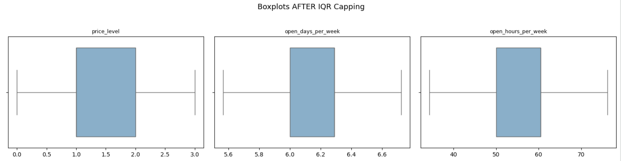
Correlation matrices before and after capping showed minimal change, validating the approach’s stability.
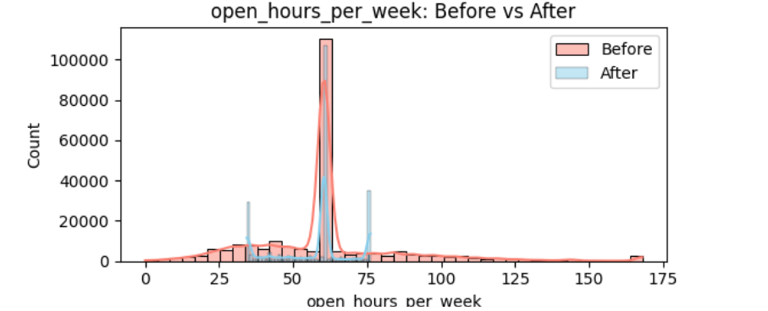
3.3. Outputs
This phase was about data integrity over automation. Rather than filling or trimming blindly, every imputation and capping decision followed the data’s logic — reflecting restaurant behavior, not just numeric thresholds.
The resulting dataset (df_after_outliers.pkl) is s a dataset that’s complete, consistent, and statistically balanced, preserving the story each restaurant tells while removing the distortions that could mislead a model.

4. Feature Engineering — Turning Data into Insight
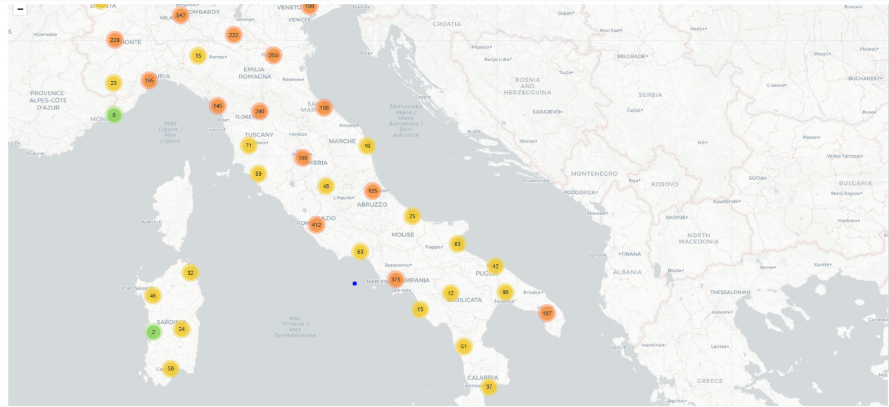
This is what the feature engineering stage was all about: enriching the raw data with new, meaningful signals that could help explain why some restaurants succeed more than others This was the most creative stage where designing new variables that captured how restaurants actually operate and compete.
4.1. Chain Identification
Repeated restaurant names flagged chains (is_restaurant_chain = 1).
This highlighted brand-driven advantage and consistent quality effects.
4.2 Spatial Context
Using BallTree and the Haversine formula:
- Computed restaurant density within 800m (area_popularity_raw / _0_100).
- Labeled top 5% densest zones as is_tourist_attraction.
- Calculated distance from each restaurant to its city center, quantifying location centrality.
4.4 Regional Economic Features
- Regional averages for price (avg_max_price_per_region, avg_price_level_per_region)
- Restaurant density per region (restaurant_density_region)
- Hybrid michelin_x_price to mix prestige and affordability.
4.5 Text-Based Signals
From address, extracted foot traffic proxies using keywords like piazza, station, airport, centro storico.
This became the addr_foot_traffic_flag.
4.6 Popularity Extraction
Parsed patterns from popularity_detailed (e.g., “#12 of 230”) to derive:
- popularity_rank, num_restaurants_per_city, and
- relative_popularity_rank — a direct measure of competitive standing.
4.7 City Size & Geography Validation
Categorized cities by restaurant count (small, medium, large) and verified coordinates were within Italy’s geographic bounds.
This ensured clean spatial logic.
4.8 Finalization
Dropped redundant or high-cardinality text fields, cast remaining strings to categorical types, and saved the enhanced dataset as df_after_feature_engineering.pkl.

5. Feature Selection, Imbalance and Model Selection
I began with the output of the feature engineering phase (df_after_feature_engineering.pkl), which contained both numeric and categorical predictors and the binary target column (1 = highly rated & well-reviewed).
Before modeling, I made a key design choice: rather than treating this as a simple classification task, I would build a modular machine learning pipeline that could be reused and fairly compared across multiple algorithms.
5.1. Splitting the Data Thoughtfully
To ensure reliable evaluation, I split the dataset into:
- 80% training,
- 20% testing,
while maintaining the class balance via stratified sampling (stratify=y).
This preserved the proportion of high-performing vs. regular restaurants across both sets which is essential when dealing with class imbalance.
5.2. Preprocessing Pipelines
Next came the data preparation pipeline:
- Numeric features were imputed using the median (robust to skewed distributions).
- Categorical features were imputed with one-hot encoded with handle_unknown="ignore", ensuring the model could handle new unseen categories without crashing.
All transformations were encapsulated in a single ColumnTransformer, which allowed the same logic to be applied consistently during both training and inference.
5.3. Feature Selection Strategy
Feature selection was handled in two steps:
- VarianceThreshold (VT) — removed near-constant columns that added no variability.
- SelectKBest (Mutual Information) — ranked features by their informational contribution to the target and kept the top 30 predictors.
This combination ensured that only independent, meaningful signals reached the model, reducing overfitting and computation time.
5.4. Tackling Class Imbalance
Because high-performing restaurants (target = 1) were fewer than the rest, I used SMOTE (Synthetic Minority Over-sampling Technique).
SMOTE generates synthetic examples of the minority class by interpolating between similar cases.
This approach balances the dataset without simple duplication, allowing models to generalize rather than memorize.

5.5. The Unified Modeling Pipeline
Every model shared the same structure:
Pipeline([
("pre", preprocessor),
("var", VarianceThreshold),
("sel", SelectKBest),
("smote", SMOTE),
("clf", Classifier)
])
This ensured that all models were tested under identical preprocessing, feature selection, and sampling conditions — making their performance directly comparable.
5.6. Candidate Models
I experimented with several classifiers, each trained and evaluated using the exact same pipeline:
Model | Description
Random Forest | Ensemble of decision trees using bagging and feature randomness for robustness.
Logistic Regression | Interpretable linear baseline, good for probability calibration.
XGBoost | Gradient-boosted trees optimized for performance and non-linearity.
Decision Tree | Simple tree to visualize decision boundaries.
Gradient Boosting (GBM) | Sequential ensemble method emphasizing hard-to-predict samples.
Linear SVM | Margin-based classifier optimized for linearly separable patterns.
AdaBoost | Adaptive boosting model that reweights misclassified instances.
Each model produced detailed test metrics:
- ROC-AUC for discrimination ability,
- F1-score for harmonic balance between precision and recall,
- Accuracy, Precision, Recall, and Log Loss for interpretability.
All results were stored in a central phase1_results_df.joblib, forming a transparent experiment log.
5.7. Leaderboard and Winner Selection
After running all models, I assembled a leaderboard sorted by Test ROC-AUC — the most stable metric for imbalanced data.
The top performer was chosen automatically for further fine-tuning.
5.8. Hyperparameter Tuning
For the winning model XGBoost, I performed Grid Search with Stratified 5-Fold Cross-Validation to fine-tune its key parameters:
- : tuned n_estimators, learning_rate, and max_depth.
The goal was not just to maximize scores but to find stable, generalizable settings that avoided overfitting.
5.9. Final Evaluation and Visual Diagnostics
After tuning, I evaluated the final model on the held-out test set.
The resulting metrics were summarized in a clean table and supported by visual diagnostics:
- ROC Curve showing sensitivity vs. specificity trade-offs,
- Precision–Recall Curve highlighting performance on minority classes,
- Normalized Confusion Matrix for class-level accuracy insights.
These plots helped confirm that the model performed consistently across success levels.
5.10. Understanding What Drives Success
Feature selection and model introspection revealed which factors most strongly predicted restaurant success.
Using the trained SelectKBest scores and, where applicable, tree-based feature importances, I extracted and saved:
- selected_features.csv — top 30 features ranked by mutual information,
- selected_features.json — for programmatic use,
- A bar chart of top predictors for visual interpretation.
Typical top features included:
- Geographic and regional indicators (region_Center, area_popularity_0_100),
- Operational signals (is_full_week, shift_length_hours),
- Inclusivity variables (is_full_diet_friendly, default_language_English),
- Economic and prestige metrics (price_level, michelin_x_price).
This reinforced earlier hypotheses: success on Tripadvisor isn’t just about cuisine quality — it’s shaped by visibility, inclusivity, and accessibility.
5.11. Results & Deliverables
All final outputs were saved for reproducibility:
- Final model: best_Tuned_<Model>_pipeline.joblib
- Selected features: selected_features.csv / .json
- Optimal parameters: chosen_params.json
- Performance metrics: selected_model_metrics.csv
The workflow ensured full transparency, from preprocessing to final deployment.

